Type the Title of Your Paper
(13pt, Bold, Times New Roman, Capitalize first letter of each word except articles, conjunctions and prepositions)

First Author¹, Second Author^{2, *}, Third Author³ (12pt, Times New Roman)
¹First Authors affiliation, Address, City and Country, email (8pt, Times New Roman)
²Second Authors affiliation, Address, City and Country, email (8pt, Times New Roman)
³Third Authors affiliation, Address, City and Country, email (8pt, Times New Roman)

Abstract Should be in Times in New Roman and font size is 9 pts.
Background
Purpose
Research Methodology
Result
Conclusion
Implications
Originality
Keywords—

  - Content
The paragraphs continue from here and are only separated by headings, subheadings, images and formulae. The section headings are arranged by numbers, bold and 10 pt. Here follows further instructions for authors. Line spacing should be 1.15.

Margin should be 1” for top,1” for bottom, 1” for left and 1” for right for the first page and top, bottom, left and right should be 1” for all other pages.

1.2. Tables

All tables must have numbers written in regular numbers (like 1, 2, 3). Put titles on top of tables and make sure they're in the center. Leave a blank line between the title and the table. Only use straight lines inside tables to show where columns start and end. Also, add lines right above and below the table. Tables should be part of the text, not separate. Here's an example that might help authors. Tables should have a font size of 8 points.

Table 1. An example of a table

An example of a column heading | Column A | Column B
Row 1
Row 2
Row 3
1.3 Figure
All figures, diagrams, graphs, and sketches in your paper should be labeled with regular numbers (1, 2,...n). Line drawings must be of high quality, either scanned well or produced electronically. Poor-quality scans won't be accepted. Embed figures into the text, don't send them separately. Ensure that all lettering and symbols are clearly explained either in the caption or in a legend included in the figure. Place figures at the top or bottom of a page whenever feasible, as near as possible to where they are first mentioned in the paper. Below each illustration, type the figure number and caption using 8-point font and center alignment.

Equations and formulae should be typed in equation editor and numbered consecutively with Arabic numerals in parentheses on the right-hand side of the page (if referred to explicitly in the text),
(Equation 1)
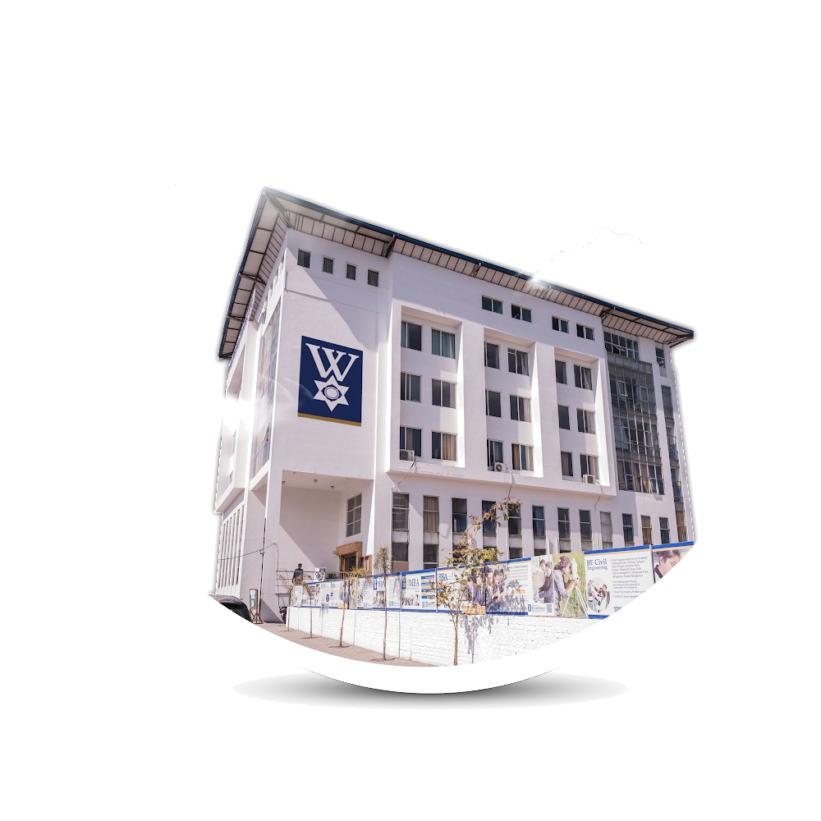

Figure 1. Sample of image

1.3. Construction of references

At the end of the paper, include a list of references. Each reference should be cited in the order it appears in the text. Make sure every reference follows the APA-7 format. The font size for the reference section should be 10 points, with 1.5 line spacing.
Basic Structure of Content
Introduction

Review of Literature

Research Methodology

Results

Discussion

Conclusion

Limitations and Directions for the Study

Acknowledgement

Conflict of Interest

References

Agrawal, A., Jaffe, J. F., & Mandelker, G. N. (1992). The Post-Merger Performance of Acquiring Firms: A Re-Examination of an Anomaly. The Journal of Finance, 47(4), 1605-1621. Retrieved from https://doi.org/10.2307/2328956
Bernolak, I. (1997). Effective measurement and successful elements of company productivity: The basis of competitiveness and world prosperity. International Journal of Production Economics, 52(1-2), 203-213. https://doi.org/10.1016/S0925-5273(97)00026-1
Appendices (optional)

